Logo of Research center/ college/external entity

**Summer Research Internship Program 2024**

***برنامج التدريب الصيفي الرابع للبحوث 2024***

(Organized by Qatar University Young Scientists Center)

***(مُنظّم من قبل مركز العلماء الشباب بجامعة قطر)***

**Track/** المسار**: TRACK 1**

**Project name/** اسم المشروع**: Indoor IoT based Air Quality Monitoring System**

**FINAL REPORT**

**التقرير النهائي**

Student Name/ اسم الطالب: Fahad ALI

Student QUID/ رقم الطالب الجامعي:202315590

College/ الكلية: College of engineering

Department/ القسم: electrical engineering

Mentor Name/ اسم المرشد: ___________ Dr. Amith Khandakar

____________

Comments by the Mentor:

Mentor Approval (Digital Signature)/ موافقة المرشد (توقيع رقمي): _________________

# Abstract

# This summer research project aimed to develop an advanced indoor air quality monitoring system designed to enhance safety through real-time detection of hazardous gas concentrations, particularly in the context of Qatar’s waste management facilities and agricultural areas. The system integrates a manually operated robotic car equipped with an ESP32 microcontroller, MATLAB for control and data visualization, and an MQ-135 gas sensor. The MATLAB-based graphical user interface (GUI) allows users to navigate the robotic car through indoor environments for targeted monitoring of specific areas.

# The MQ-135 gas sensor continuously measures concentrations of ammonia, nitrogen oxides, and carbon dioxide, which are common pollutants in waste management and agricultural environments. Data collected by the sensor is processed by the ESP32 microcontroller and displayed in real time on the Blynk platform, which also sends instant notifications to mobile devices when gas levels exceed predefined safety thresholds.

# The primary objective was to deliver an efficient and user-friendly solution for indoor air quality management. The system's mobility and real-time monitoring capabilities represent a significant advancement over traditional stationary air quality monitors. Extensive testing across various indoor settings has confirmed the system's effectiveness, establishing it as a valuable tool for maintaining and managing indoor air safety, particularly in environments prone to hazardous gas emissions such as those in Qatar’s waste management and agricultural sectors.

# BACKGROUND

I had a strong background in electronics, microcontrollers, and control systems from my studies for an electrical engineering degree, which I completed before starting the internship. Developing an air quality monitoring system is directly related to the extensive courses I completed in circuit design, signal processing, and embedded systems during my academic career. Through the QUYSC 2024 Summer Research Internships program, in addition to my technical background, I acquired invaluable expertise in research methodology. I took use of all the available research techniques classes, which helped me develop critical thinking, data analysis, experimental design, and technical reporting abilities. My background in research and technological expertise equipped me to tackle the challenges of developing and executing a cutting-edge robotic system for indoor air quality monitoring during my internship.

**ROLES AND MILESTONES**

During the first week, the mentors focused on teaching us the importance of a thorough research foundation. They introduced us to the PRISMA (Preferred Reporting Items for Systematic Reviews and Meta-Analyses) method, which we used to conduct a systematic review of existing technologies related to indoor air quality monitoring.

**My Role:**

My role was to apply the PRISMA method to identify and analyze relevant studies. This involved:

* Conducting a comprehensive literature search on air quality monitoring systems.
* Screening and selecting studies that met specific criteria.
* Extracting and summarizing data from the selected studies to inform our project decisions.
* Compiled research findings for the team.

**Week 2: Component Selection and Evaluation (June 21 - June 27)**

**Knowledge Provided by Mentors:**

In the second week, the mentors provided detailed guidance on evaluating and selecting the best components for our project. They emphasized the importance of technical specifications and performance criteria when choosing components like sensors, microcontrollers, and communication modules.

**My Role:**

My role this week was to:

* Research and identify the most suitable components for the system based on the criteria discussed.
* Prepare a presentation outlining my chosen component, including its advantages and potential challenges.
* Present my findings to the group, contributing to the final decision-making process.

**Milestones Achieved:**

* Identified and evaluated potential components for the system.
* Delivered a presentation on my selected component to the team.
* Contributed to the final selection of components, finalized with input from the Dr.

**Week 3: System Integration and Initial Testing (June 28 - July 5)**

**Knowledge Provided by Mentors:**

The third week focused on integrating the selected components into a cohesive system. The mentors provided hands-on guidance on connecting the MQ-135 gas sensor with the ESP32 microcontroller and integrating these with the robotic car.

**My Role:**

My responsibilities included:

* Assisting in the integration of the chosen components into the robotic car.
* Ensuring that the ESP32 microcontroller correctly interfaced with the MQ-135 sensor.
* Collaborating with team members to begin initial testing of the integrated system.

**Milestones Achieved:**

* Successfully integrated the MQ-135 sensor with the ESP32 microcontroller.
* Conducted initial tests to ensure the components were working together as expected.
* Identified any issues that needed addressing before moving to full-scale testing.

**Week 4: Full-Scale Testing and Data Recording (July 6 - July 13)**

**Knowledge Provided by Mentors:**

In the fourth week, the mentors emphasized the importance of thorough testing and accurate data recording. They guided us on how to conduct tests systematically and how to use the Blynk platform for real-time data monitoring and alert configurations.

**My Role:**

My role was to:

* Participate in full-scale testing of the system in various indoor environments.
* Record the results meticulously, noting any deviations or anomalies.
* Configure the Blynk platform for real-time data monitoring and ensure that alerts were correctly set up.

**Milestones Achieved:**

* Completed full-scale testing of the integrated system.
* Recorded detailed results, providing valuable data for further analysis.
* Successfully configured the Blynk platform to monitor air quality in real time and send alerts for any hazardous conditions.

This breakdown reflects the progression of responsibilities and achievements over the first four weeks of the internship, showing how each phase built upon the previous one to advance the project.

**PRISMA CHART**

Studies included in review

(n = 3)

Reports of included studies

(n =3 )

**Identification**

**Included**

Reports sought for retrieval

(n =143)

Reports not retrieved

(n =56)

Reports assessed for eligibility

(n =87)

Reports excluded:

Reason 1 (n = 8 ) not directly related to our research

Reason 2 (n = 76) no clear data

Records screened

(n = 3683)

Records excluded**

(n =3540)

**Screening**

Records identified from*:

Databases (n =1 ) IEEE

Registers (n = 3960)

Records removed *before screening*:

Duplicate records removed (n = 40)

Records marked as ineligible by automation tools (n = 56)

Records removed for other reasons (n =181 )

**LEARNING OUTCOMES**

# 1. Advanced Technical Skills:

# Microcontroller Programming: Gained expertise in programming the ESP32 microcontroller, including interfacing with sensors like the MQ-135 and integrating it into a larger system.

# Sensor Calibration and Data Processing: Learned how to calibrate the MQ-135 gas sensor and process its data to accurately detect hazardous gases in real-time.

# MATLAB GUI Development: Developed skills in creating a MATLAB-based graphical user interface for manual control of a robotic system and data visualization.

# 2. Research and Analytical Skills:

# Systematic Review Techniques: Acquired proficiency in conducting systematic reviews using the PRISMA method, which enhanced my ability to evaluate and select the best components for the project.

# Component Evaluation: Learned how to critically assess the technical specifications and performance of different components, leading to informed decisions in the component selection process.

# 3. Practical Application and System Integration:

# Hands-on System Integration: Gained practical experience in integrating various hardware components into a cohesive system, ensuring that all parts work together seamlessly.

# Real-Time Data Monitoring: Developed the ability to set up and configure real-time data monitoring and alert systems using the Blynk platform, enhancing the system's functionality and user experience.

# 4. Collaboration and Communication:

# Teamwork: Improved collaboration skills by working closely with peers and mentors, contributing to group discussions, and making joint decisions on component selection.

# Technical Communication: Enhanced my ability to communicate complex technical information clearly and effectively, both in written presentations and during team meetings.

# 5. Problem-Solving and Adaptability:

# Troubleshooting: Learned to identify and resolve issues during the integration and testing phases, improving the system's reliability.

# Adaptability: Adapted to new challenges and technologies throughout the project, demonstrating flexibility and a willingness to learn.

# These outcomes reflect the comprehensive learning experience provided by the internship, combining technical, research, and soft skills essential for success in future engineering projects.

**FEEDBACK**

# Strengths:

# Comprehensive Learning: The program effectively integrated theoretical knowledge with practical application, providing a well-rounded educational experience.

# Supportive Mentors: Mentors offered valuable guidance, ensuring clear understanding of complex concepts and assisting with technical challenges.

# Hands-On Experience: Direct interaction with advanced technologies like the ESP32 microcontroller, MQ-135 sensor, and MATLAB significantly enhanced practical skills and understanding.

# Collaboration: The program promoted strong teamwork and communication, facilitating learning through peer interaction and collective problem-solving.

# Opportunities:

# Skill Development: The internship provided extensive opportunities to develop technical and research skills, directly applicable to future engineering projects and professional work.

# Networking: Enabled connections with industry professionals, mentors, and peers, potentially leading to future collaborations and career opportunities.

# Innovative Thinking: Fostered an environment of creative problem-solving and critical thinking, particularly in integrating new technologies and designing real-time monitoring systems.

# Enhanced Project Management: Gained experience in managing project timelines and adapting to evolving requirements, which will be beneficial for future projects.

# Threats:

# Technical Challenges: Encountered issues with sensor calibration and system integration that required troubleshooting, which could impact project timelines.

# Dependency on Tools: Reliance on external platforms like Blynk introduced potential vulnerabilities, such as platform outages or limitations, affecting system reliability.

# Resource Competition: Competition for limited resources among participants occasionally led to delays or restricted access to necessary tools, impacting progress.

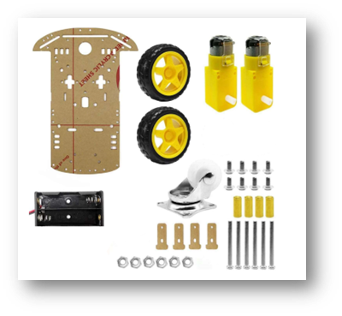**ANNEXES**

**Hardware components:**

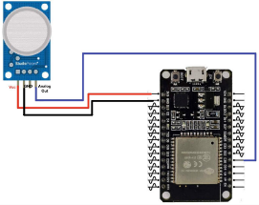

Final prototype:

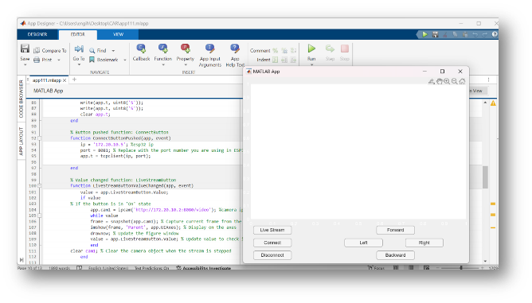

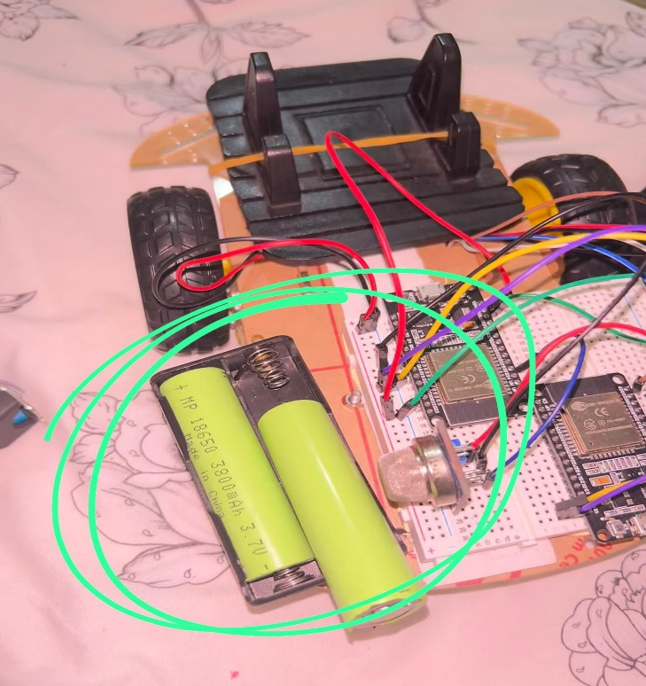

This report was made possible through the research work performed during the Summer Research Internship Program 2024 (SRIP24), organized by the Qatar University Young Scientists Center (QUYSC) under the guidance of the Office of the Vice President for Research & Graduate Studies (VPRGS).

**REFRENCES**

* 1. Nasution, T.H., Muchtar, M.A. and Simon, A., 2019, October. Designing an IoT-based air quality monitoring system. In *IOP conference series: materials science and engineering* (Vol. 648, No. 1, p. 012037). IOP Publishing.
  2. Ullo, S.L. and Sinha, G.R., 2020. Advances in smart environment monitoring systems using IoT and sensors. *Sensors*, *20*(11), p.3113.
  3. Tran, V.V., Park, D. and Lee, Y.C., 2020. Indoor air pollution, related human diseases, and recent trends in the control and improvement of indoor air quality. *International journal of environmental research and public health*, *17*(8), p.2927.
  4. Islam, M.M., Rahaman, A. and Islam, M.R., 2020. Development of smart healthcare monitoring system in IoT environment. *SN computer science*, *1*, pp.1-11.
  5. Kumar, A., Kumari, M. and Gupta, H., 2020, February. Design and analysis of iot based air quality monitoring system. In *2020 International Conference on Power Electronics & IoT Applications in Renewable Energy and its Control (PARC)* (pp. 242-245). IEEE.
  6. Shah, H.N., Khan, Z., Merchant, A.A., Moghal, M., Shaikh, A. and Rane, P., 2018. IOT based air pollution monitoring system. *International Journal of Scientific & Engineering Research*, *9*(2), pp.62-66.
  7. Hawari, H.F., Zainal, A.A. and Ahmad, M.R., 2019. Development of real time internet of things (IoT) based air quality monitoring system. *Indonesian Journal of Electrical Engineering and Computer Science (IJEECS)*, *13*(3), pp.1039-1047.
  8. Kumar, S. and Jasuja, A., 2017, May. Air quality monitoring system based on IoT using Raspberry Pi. In *2017 International conference on computing, communication and automation (ICCCA)* (pp. 1341-1346). IEEE.
  9. Rawal, R., 2019. Air quality monitoring system. *International Journal of Computational Science and Engineering*, *9*(1), pp.1-9.
  10. De Medeiros, H.P.L. and Girão, G., 2020, September. An IoT-based air quality monitoring platform. In *2020 IEEE international smart cities conference (ISC2)* (pp. 1-6). IEEE.
  11. Jo, J., Jo, B., Kim, J., Kim, S. and Han, W., 2020. Development of an IoT‐based indoor air quality monitoring platform. *Journal of Sensors*, *2020*(1), p.8749764.
  12. Kodali, R.K. and Rajanarayanan, S.C., 2019, March. IoT based indoor air quality monitoring system. In *2019 International Conference on Wireless Communications Signal Processing and Networking (WiSPNET)* (pp. 1-5). IEEE.
  13. Gupta, H., Bhardwaj, D., Agrawal, H., Tikkiwal, V.A. and Kumar, A., 2019, February. An IoT based air pollution monitoring system for smart cities. In *2019 IEEE International Conference on Sustainable Energy Technologies and Systems (ICSETS)* (pp. 173-177). IEEE.
  14. Purkayastha, K.D., Mishra, R.K., Shil, A. and Pradhan, S.N., 2021. IoT based design of air quality monitoring system web server for android platform. *Wireless Personal Communications*, *118*(4), pp.2921-2940.
  15. Muthukumar, S., Mary, W.S., Jayanthi, S., Kiruthiga, R. and Mahalakshmi, M., 2018, July. IoT based air pollution monitoring and control system. In *2018 International Conference on inventive research in computing applications (ICIRCA)* (pp. 1286-1288). IEEE.